Season’s Greetings

ARYA RAJIV CHALOLI

PES1201700253

CLASS 3B

# The Search Begins

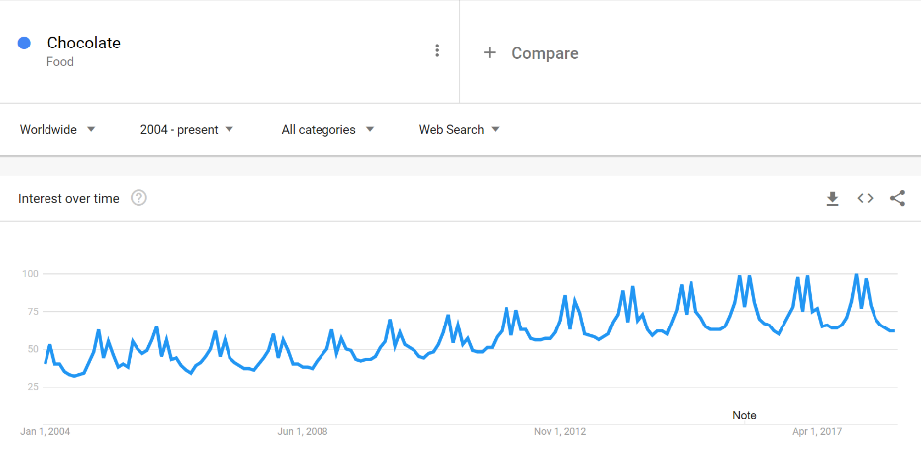The trend of ‘chocolate’ worldwide since 2004 had been analysed. There was a yearly periodicity in the number of searches and it was also observed that there is a gradual increase in the trend.

# Zooming In

To observe the reason for this periodicity in trend of the searches about ‘chocolate’, we zoom into an interval of 5 years. It has been observed that there are primary three peaks yearly.The times of the year that the three peaks corresponded to were December end, mid-February, and March end.

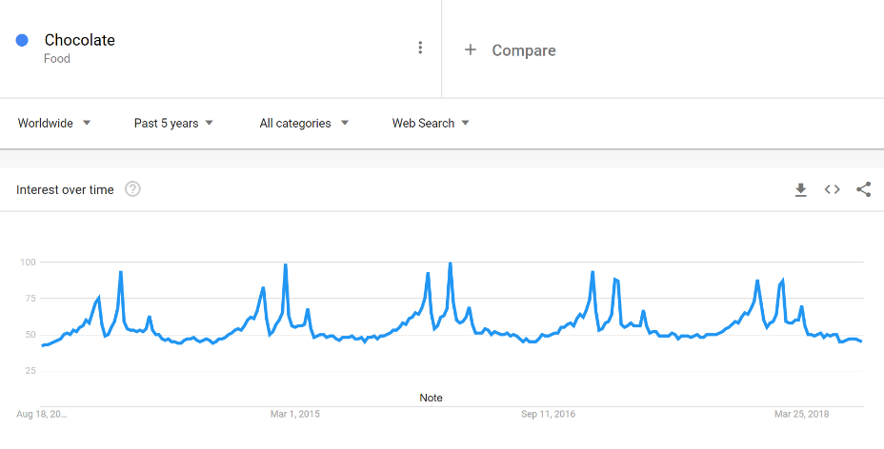Intuitively it could be inferred that, the dates corresponded to Christmas, Valentine’s day and Easter.

# Confirming The Hypothesis

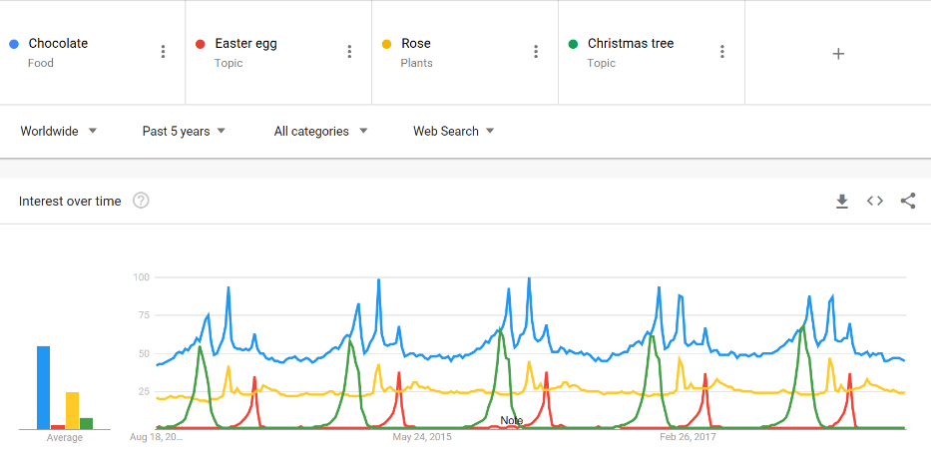To confirm this hypothesis, the trend in the search for the words Christmas trees, roses and Easter eggs were searched. The results were positive and the hypothesis could be confirmed.

# India’s take

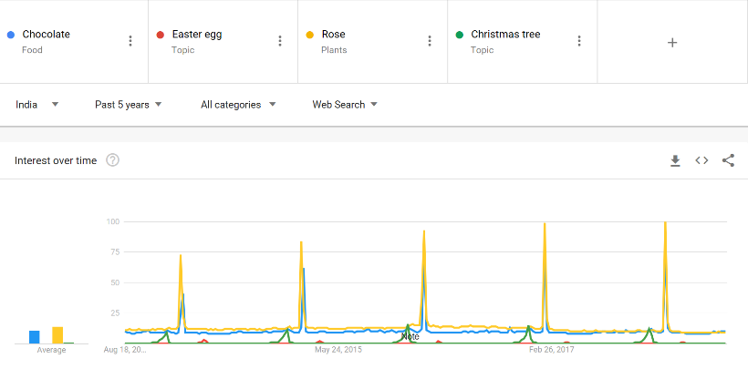Retaining the same parameters, the geographic region of the trend analysis was changed from ‘Worldwide’ to ‘India’.

The data obtained had the following inferences:

1. The trend of chocolates peaked only at one point every year which corresponded to Valentine’s Day.
2. The trend of roses peaked at the same time and to a greater extent as compared to chocolates.
3. The trend of Christmas trees is rather small but consistent every Christmas.
4. The trend of Easter eggs is rather small and reducing as the years go on.

The analysis is now focussed into chocolates, roses and Valentine’s day. It is observed that all the three peak every year around the time of the Valentine’s day.

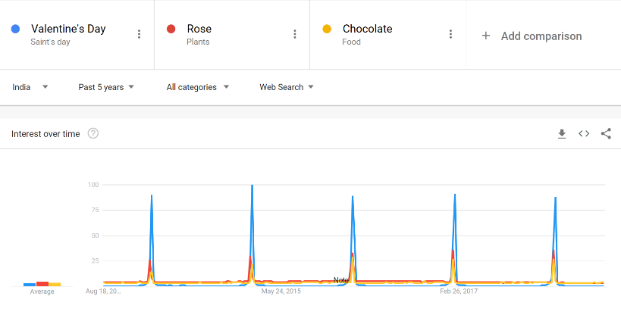

## Chocolates

Interest for chocolates on Valentine’s day have increased over time which has been steady off-late.

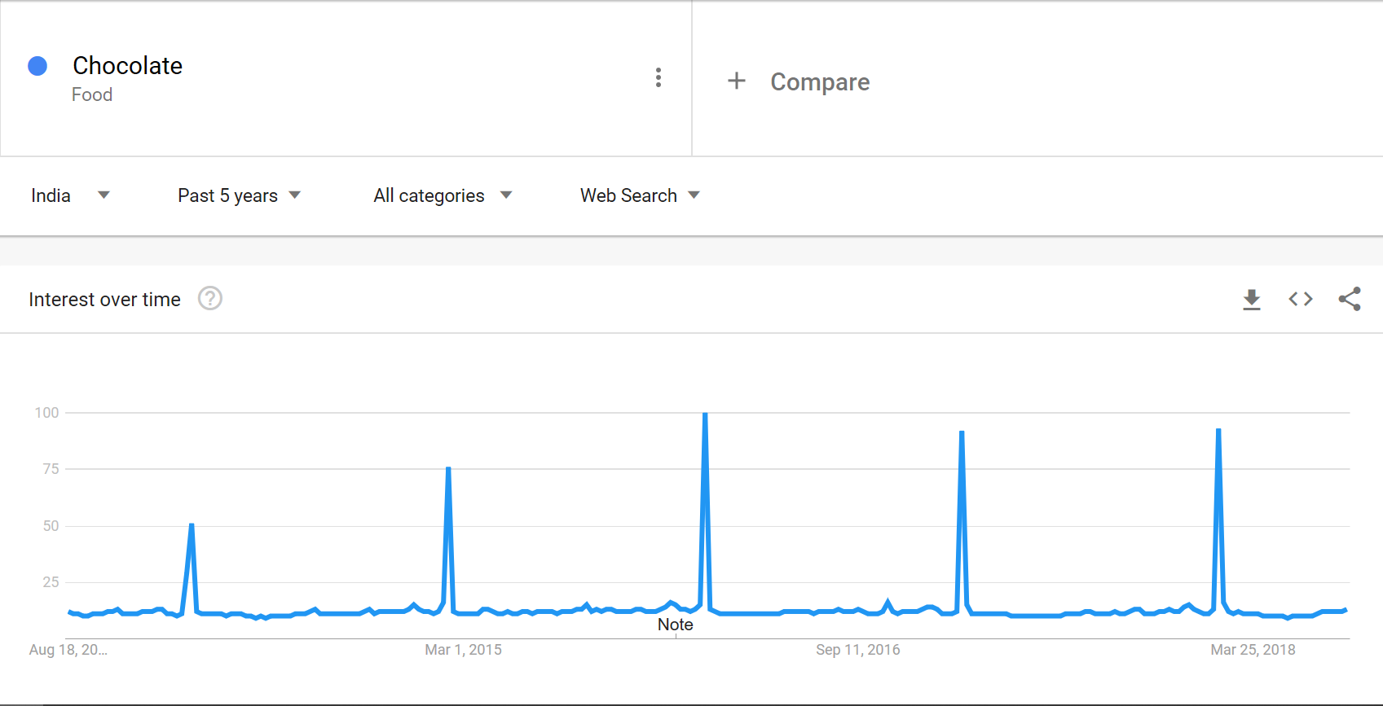

And the highest search interests are from Goa, Maharashtra, Karnataka etc.

## Roses

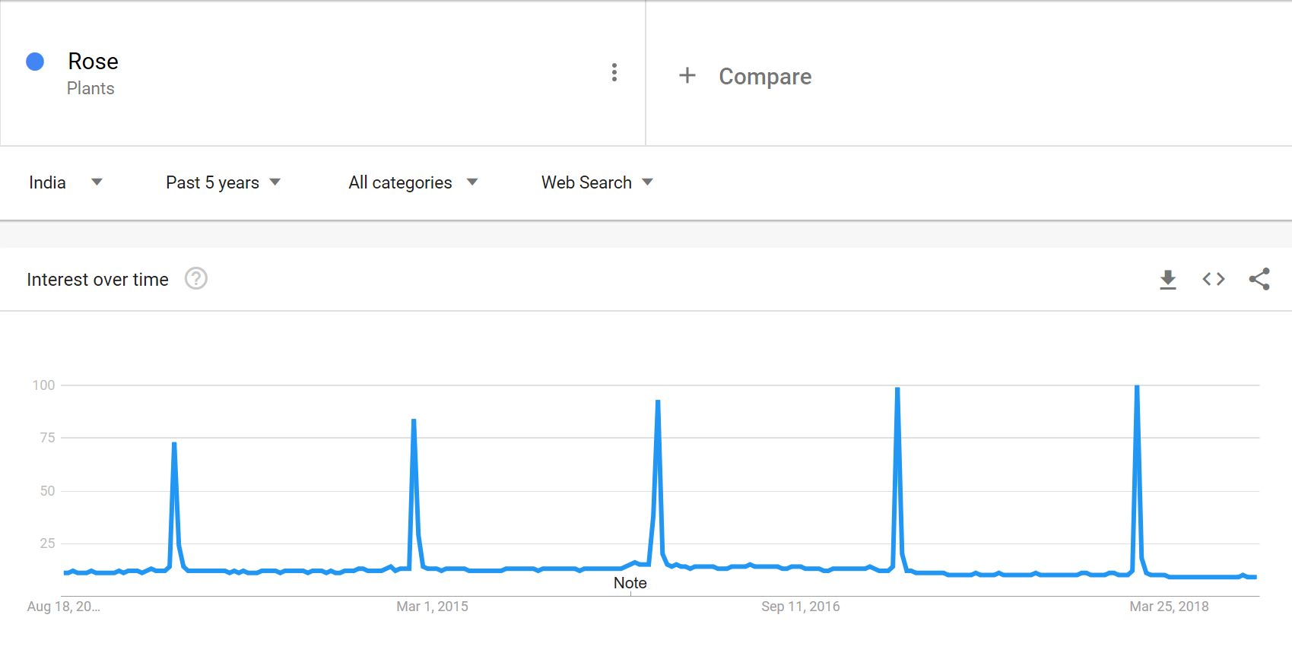Interest for roses on Valentine’s day have had a steady increase over the years.

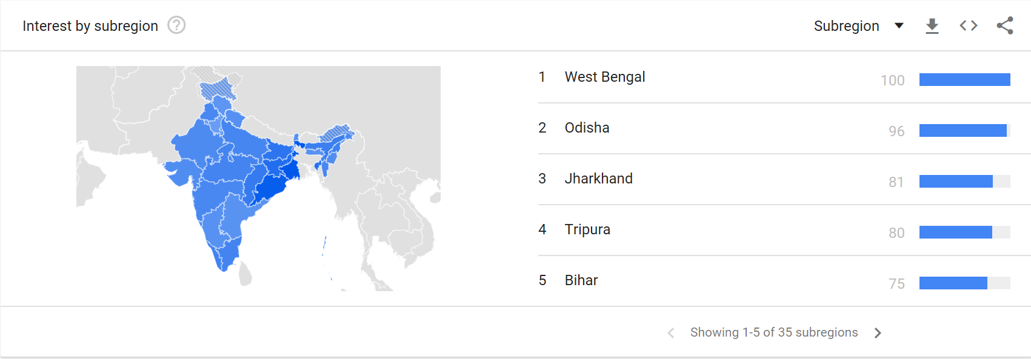And the highest search interests are from West Bengal, Odisha etc.